**Project Documentation**

**Project** **Title :** Cook Book: Your Virtual Kitchen Assistant

**Team** **ID** **:** NM2025TMID37537

**Team** **Size** **:** 4 Team

**Team Leader :**

**Name** **:** Jayanthi. S

**Email** **id** **:** jayanthijayanthi2504@gmail.com

**Team Members :**

**1.** **Name** **:** Killari Thejasri. S

**Email** **id** **:** thejasubramani181083@gmail.com

**2.** **Name** **:** Keerthana. S

**Email** **id** **:** keeks2904@gmail.com

3. **Name** **:** Anushprabha. K

**Email** **id** **:** anushprabhakannan@gmail.com

**2. Introduction :**

Cooking is an essential part of our daily lives, and people are always looking for easy-to-follow recipes. Traditionally, recipes are written in notebooks or shared by word of mouth. With the rise of digital technology, most people now search for recipes online. However, many platforms are cluttered with ads and lack personalization.

The Cookbook Web Application is designed to solve this issue by providing a clean, user-friendly, and interactive digital recipe book. It allows users to browse, search, and add recipes along with images, ingredients, and preparation steps. The system is designed for simplicity and accessibility, making it useful for both beginners and professional chefs.

**3. Project Overview :**

**Purpose :**

The purpose of the project is to create a recipe management web application that allows users to store, explore, and share recipes.

**Problem Statement :**

Most existing cooking websites are overloaded with unnecessary information, making it hard for users to focus on the recipe itself. **3**Furthermore, many require sign-ups or have limited free features.

**Solution :**

Cookbook provides a lightweight web platform where users can directly access recipes, filter by categories, and add new recipes with images and details.

**Key Benefits :**

* Easy-to-use interface for all age groups
* Quick recipe browsing and searching
* Digital replacement for handwritten recipe books
* Accessible from any device (desktop, tablet, or mobile)

**Features :**

* Recipe browsing and search
* Add new recipes with title, ingredients, steps, time, and picture
* Recipe detail page with all instructions
* Responsive design for mobile and desktop

**Optional :** Categories (Veg/Non-Veg/Desserts), favourites, dark/light mode

**4. Architecture :**

The architecture of the application is modular and flexible.

**Frontend (Main Focus):**

* Built with HTML5, CSS3, JavaScript (and optionally React.js).
* Displays recipe cards, forms, and detail pages.
* Provides responsive design using CSS grid/flexbox.

**Backend (Optional Enhancement) :**

* Node.js and Express.js can handle user data and recipes.
* Provides REST APIs for recipe CRUD operations.

**Database (Optional) :**

MongoDB or MySQL stores user accounts, recipes, images, ratings.

**Workflow :**

1. User opens web app → Home page loads featured recipes.

2. User can search or filter recipes.

3. User adds new recipe through a form (stored locally or in database).

4. Recipe is displayed dynamically on the screen.

5. Setup Instructions

**Prerequisites :**

* **Browser:** Chrome/Edge/Firefox
* **Text** **editor:** Visual Studio Code

(Optional) Node.js, Express.js, MongoDB for backend

**Steps (Frontend Only) :**

1. Download the Cookbook-Project folder.

2. Place all files (index.html, style.css, script.js) together.

3. Open index.html directly in the browser.

4. Add recipes using the form and see them displayed instantly.

**Steps (Full-Stack Version) :**

**1. Clone repository :**

git clone <repo-link>

**2. Install client dependencies :**

* cd client
* npm install

**3. Install server dependencies :**

* cd ../server
* npm install

**4. Start frontend :** npmstart

**5. Start backend :** npmrunserver

**6. Folder Structure :**

Simple Frontend Version

Cookbook-Project/

│-- index.html # Main structure

│-- style.css # Styling and layout

│-- script.js # JavaScript logic

│-- images/ # Recipe pictures

│-- Dessert.jpg

│-- Biryani.jpg

**Explanation :**

* index.html: Entry point of the application.
* style.css: Defines colors, fonts, layout, responsive design.
* script.js: Handles adding, displaying, and managing recipes.
* images/: Stores local recipe images.

**Full-Stack Version :**

Cookbook-App/

│-- client/ # React frontend

│ │-- components/ # Navbar, RecipeCard, RecipeForm

│ │-- pages/ # Home, Recipes, AddRecipe

│-- server/ # Node.js backend

│ │-- routes/ # API endpoints

│ │-- models/ # Database models

│ │-- controllers/ # Business logic

**7. Running the Application :**

Frontend Only: Open index.html in a browser.

**React Frontend :**

* cd client
* npm start

**Backend :**

* cd server
* npm start

Access at http://localhost:3000

**8. API Documentation (Optional Backend) :**

**Recipes :**

* GET /api/recipes → Fetch all recipes
* POST /api/recipes/add → Add new recipe
* GET /api/recipes/:id → Get recipe details
* DELETE /api/recipes/:id → Delete recipe

**9. User Interface :**

* **Home** **Page:** Shows featured recipes with images.
* **Recipe** **List** **Page:** Displays recipes in card format (title + image + time).
* **Recipe** **Detail** **Page:** Shows full details (ingredients, steps, time).
* **Add** **Recipe** **Page:** Form for entering new recipes.
* **Responsive** **Design:** Works on desktop, tablet, and mobile.

**10. Testing :**

**Manual** **Testingm:** Checked on Chrome, Firefox, and Edge.

**Test Cases :**

* Add recipe → Appears in list immediately.
* Submit empty form → Validation prevents it.
* View details → Shows correct ingredients and steps.

**Tools Used :**

* Browser DevTools (console, responsiveness)
* Postman (if backend APIs are used)

**11. Screenshots or Demo**(Add screenshots of: Home page, Recipe list, Recipe detail, Add recipe form.)

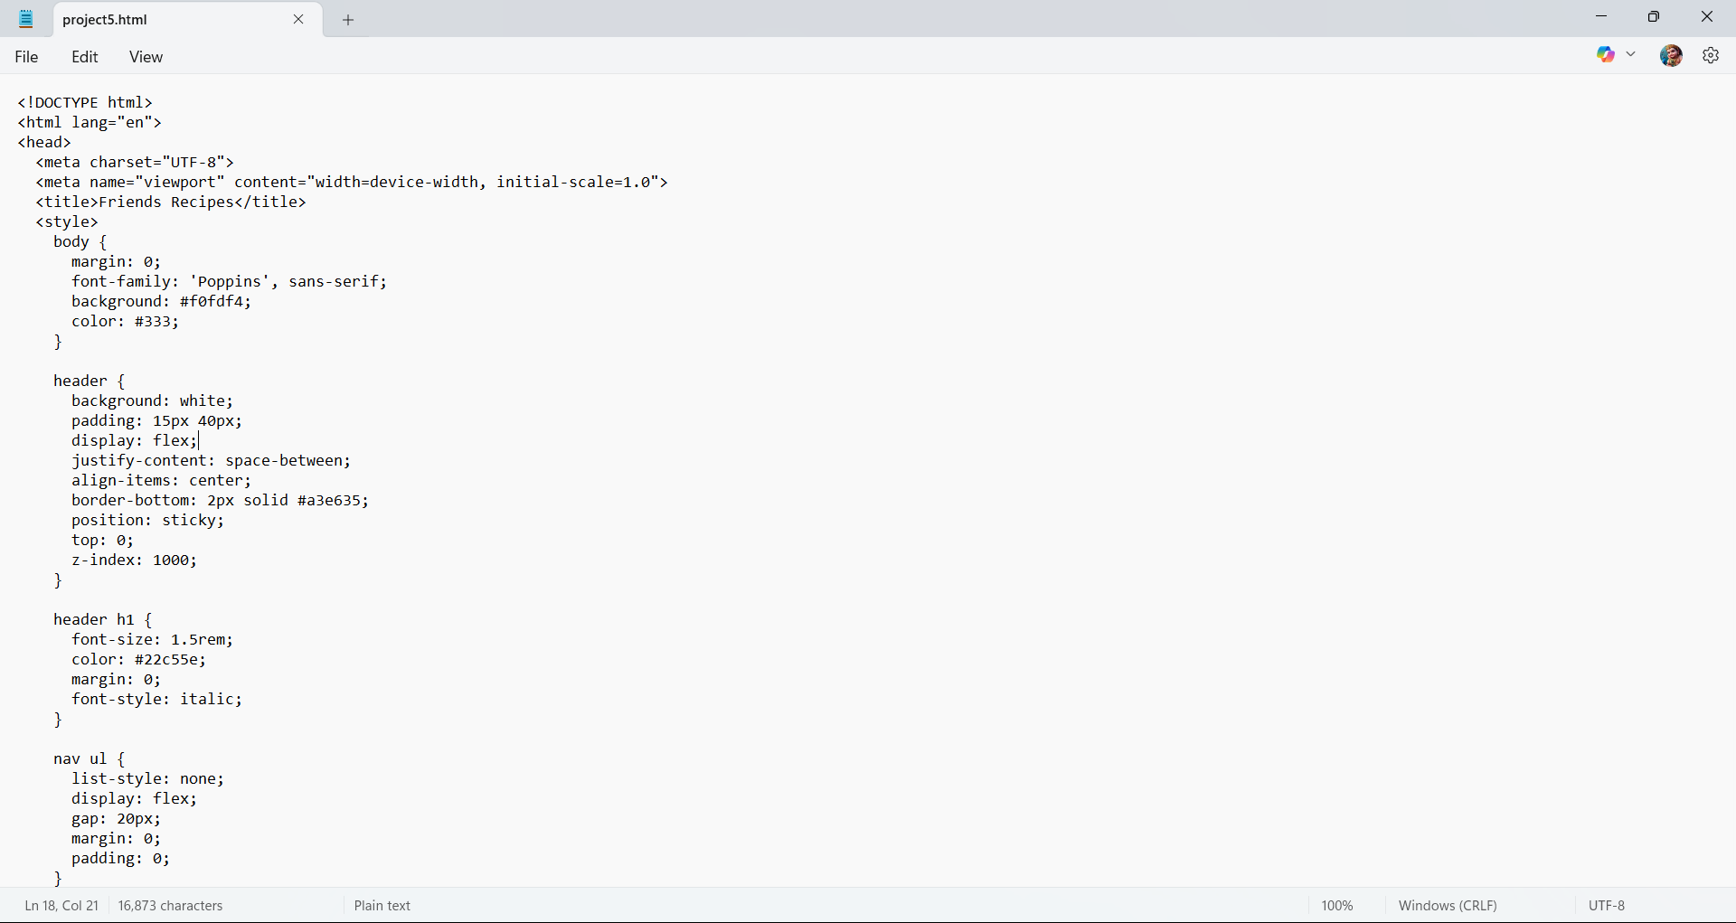

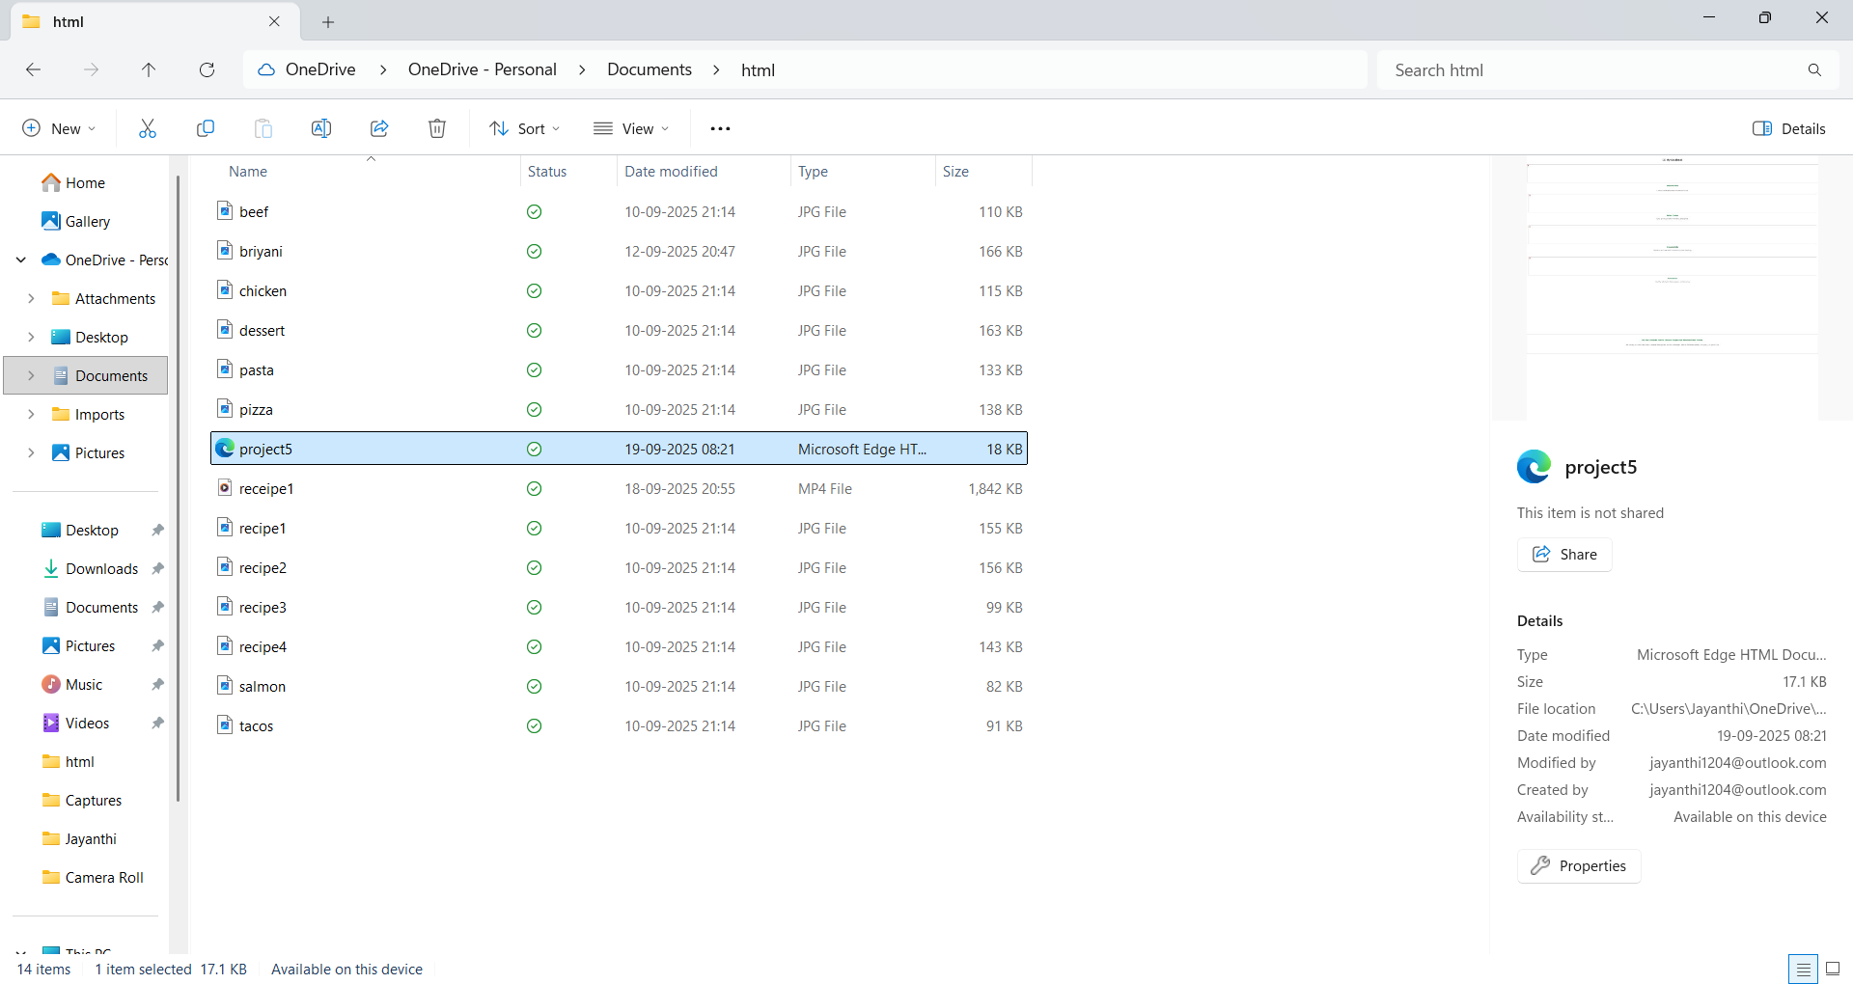

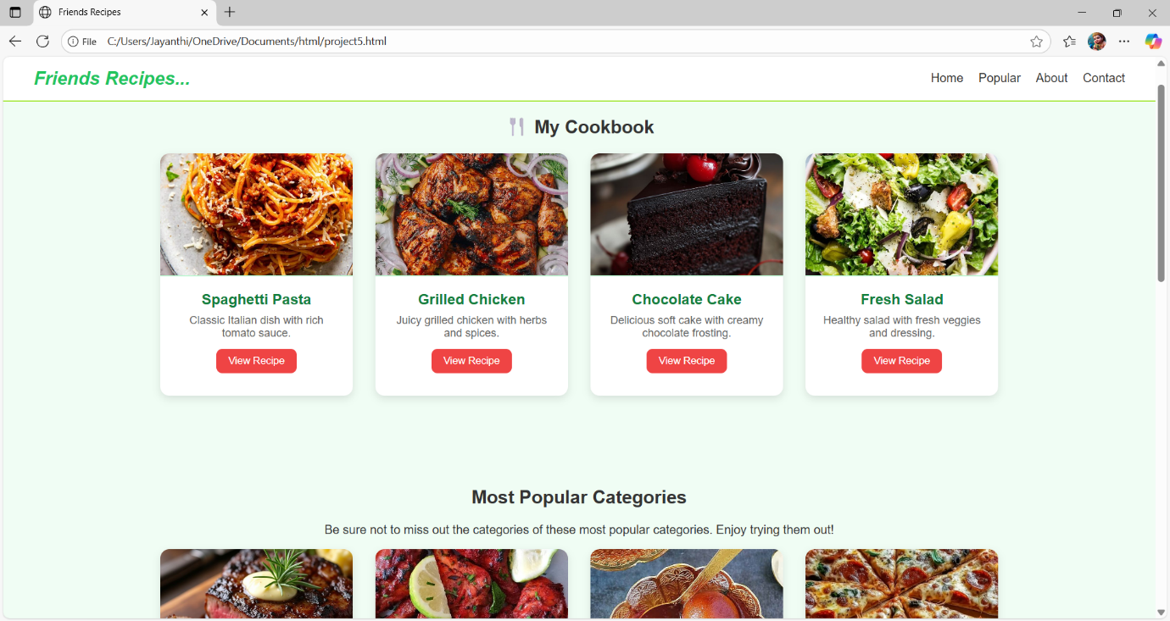

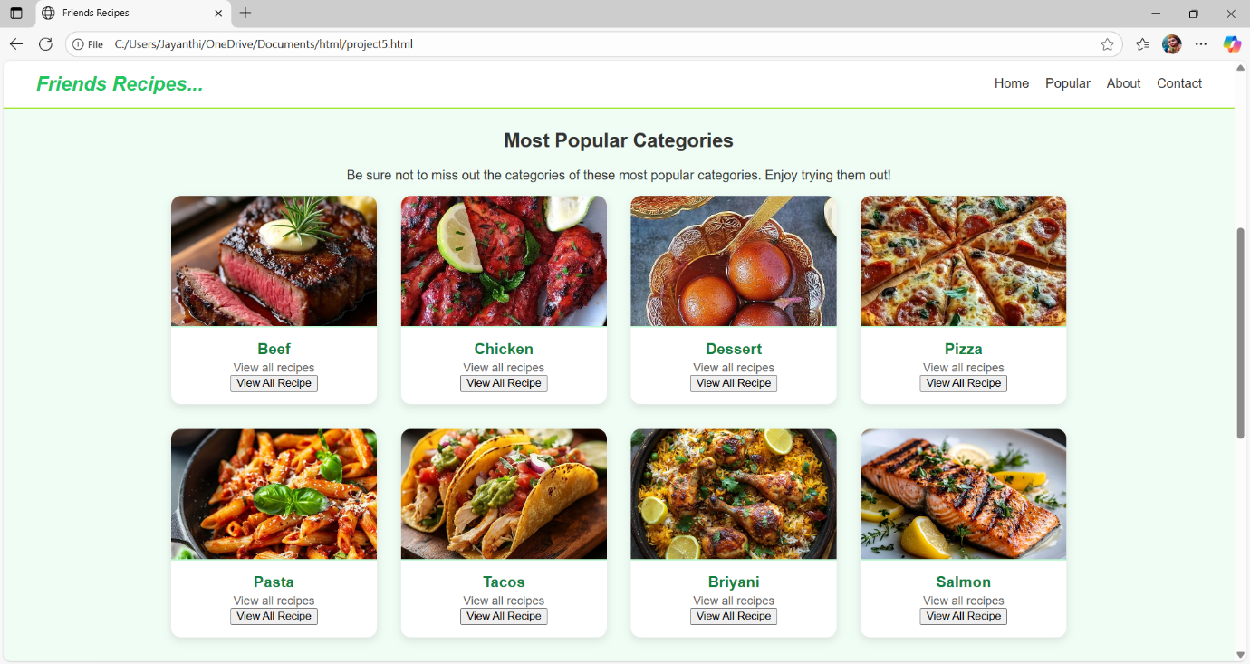

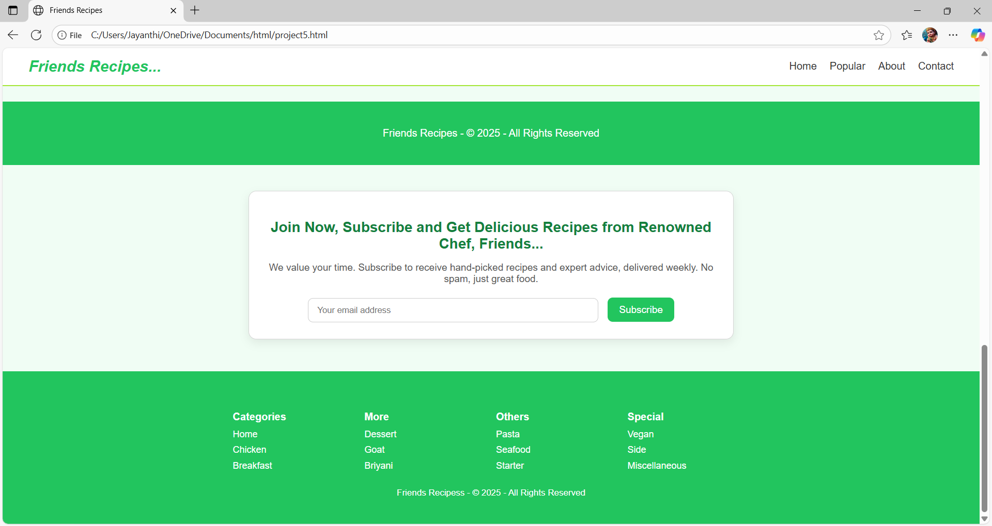

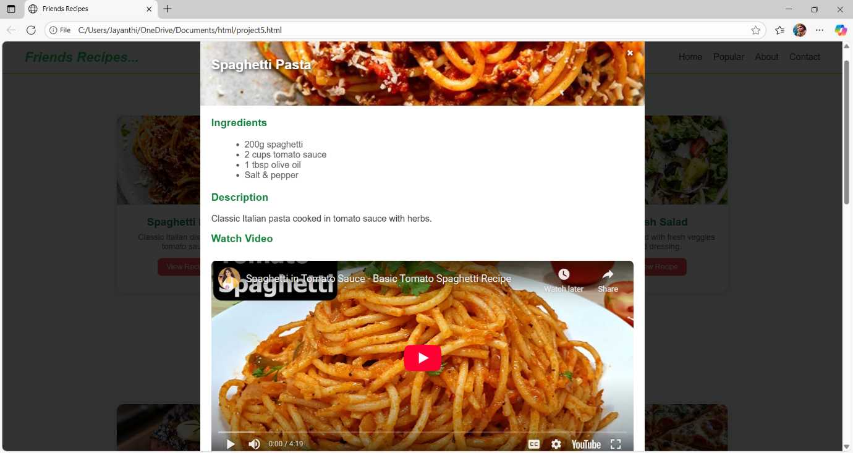

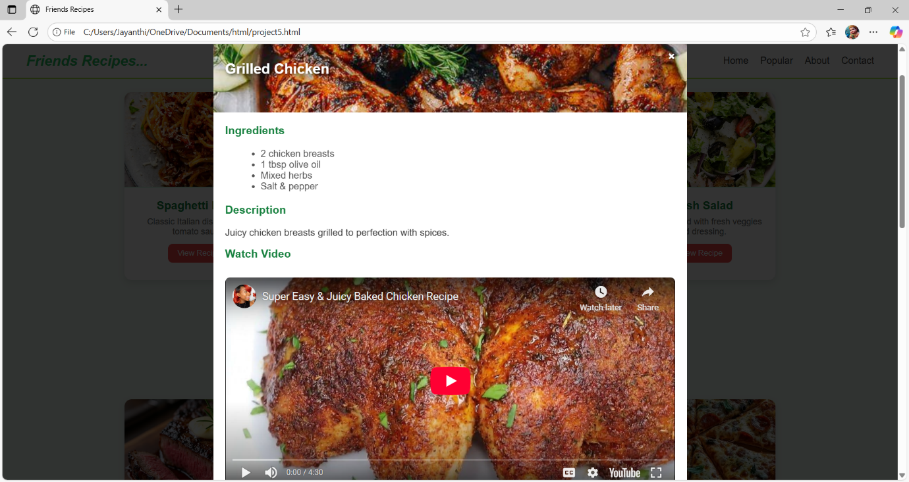

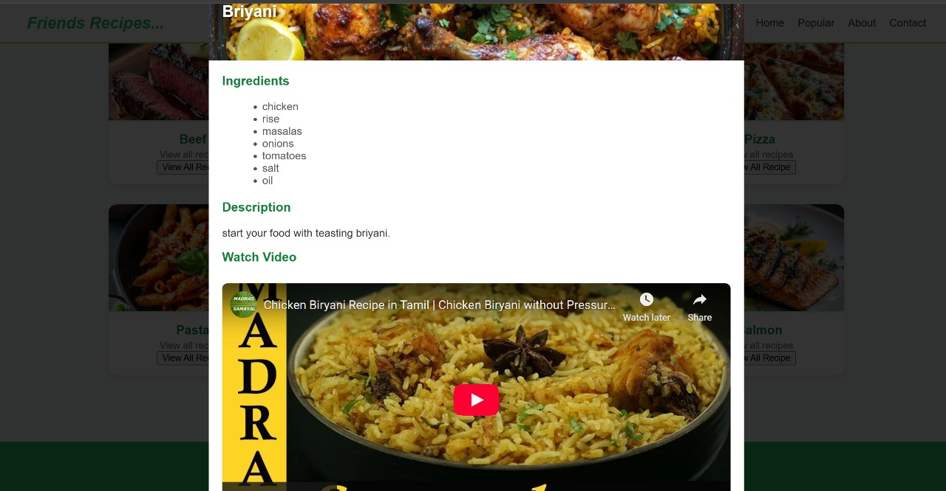

**12. Known Issues :**

* Recipes are not stored permanently in frontend-only version (lost after refresh).
* Images from external URLs may fail if the link is broken.
* No login system in the basic version.

**13. Future Enhancements :**

* Add login/signup with JWT authentication.
* Save recipes permanently in MongoDB/MySQL.
* Add categories (Veg, Non-Veg, Desserts).
* Add rating and comment system.
* AI-based recipe recommendations.